In the properties list, we have the expender feature where we display the high level information of the property in a expended view. This feature is very good for quick view of the details without opening and then go into each tab
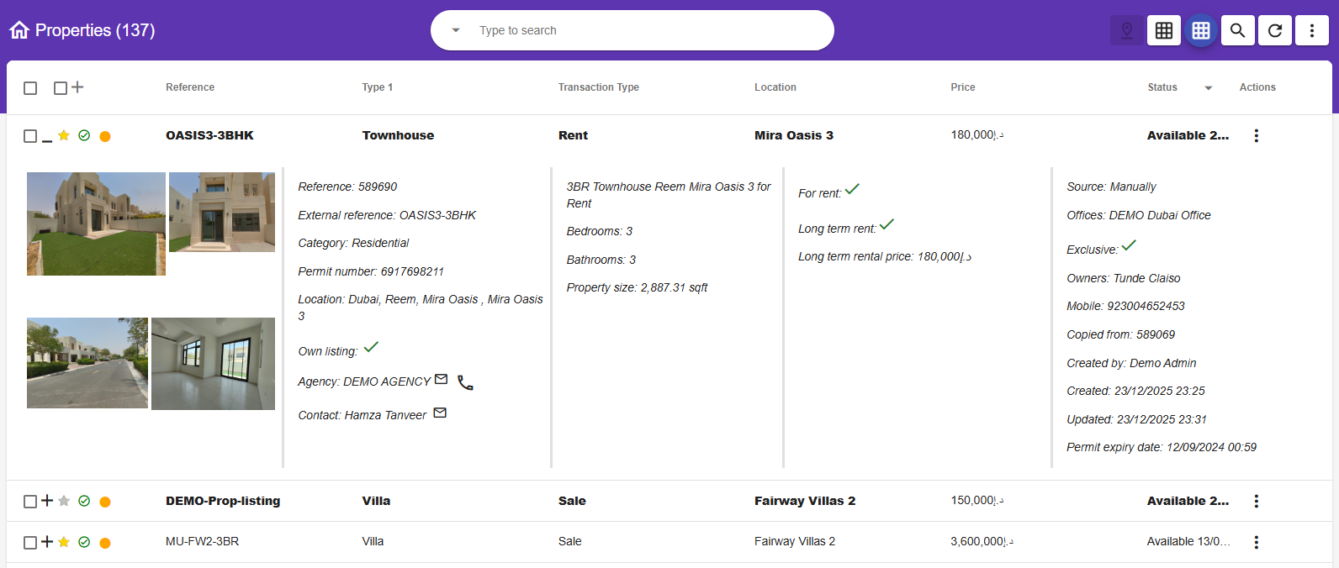

Currently for accounts, we don’t have the expender view, we are thinking to introduce it.
How currently it looks
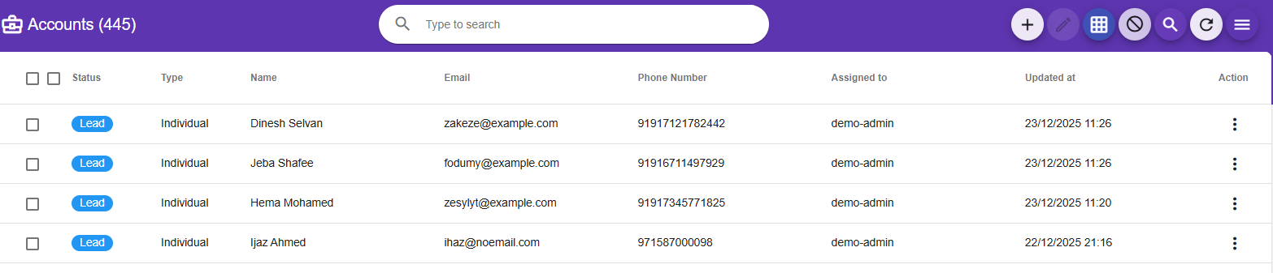

The tabs are
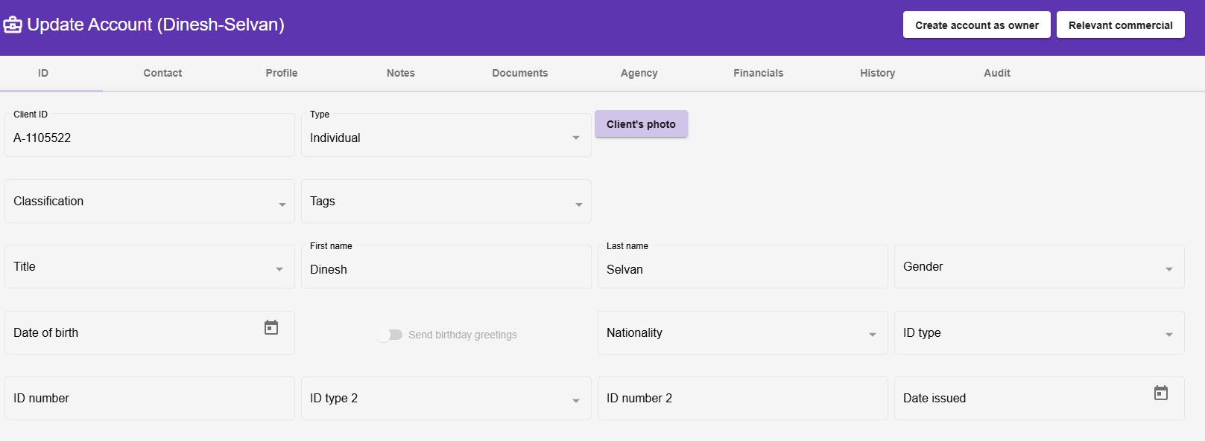
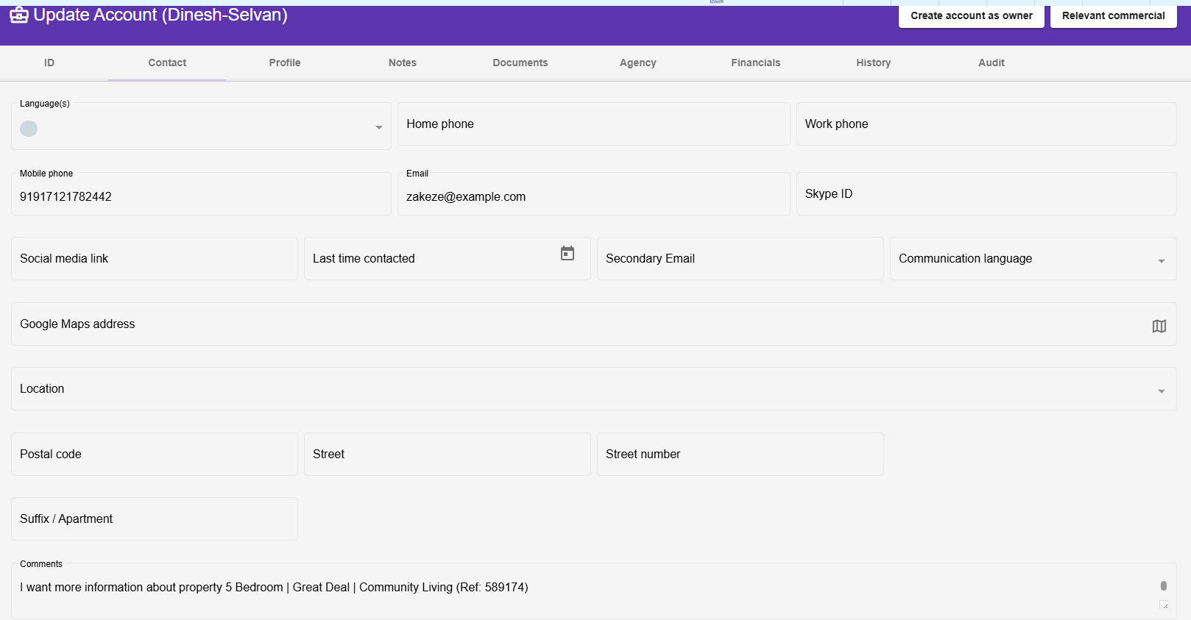
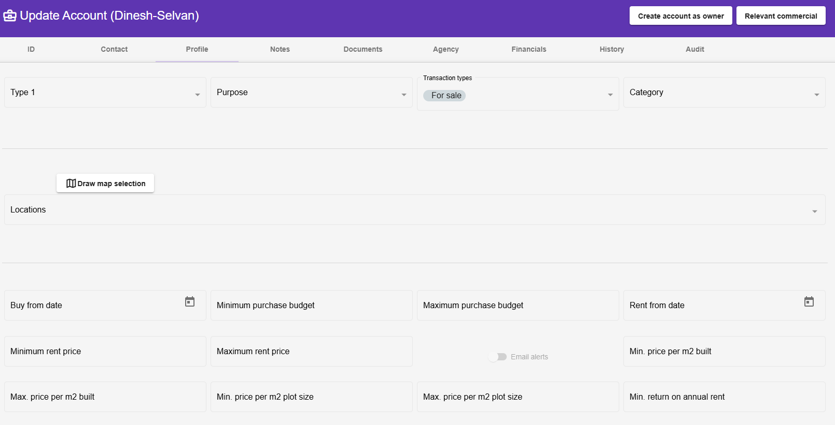
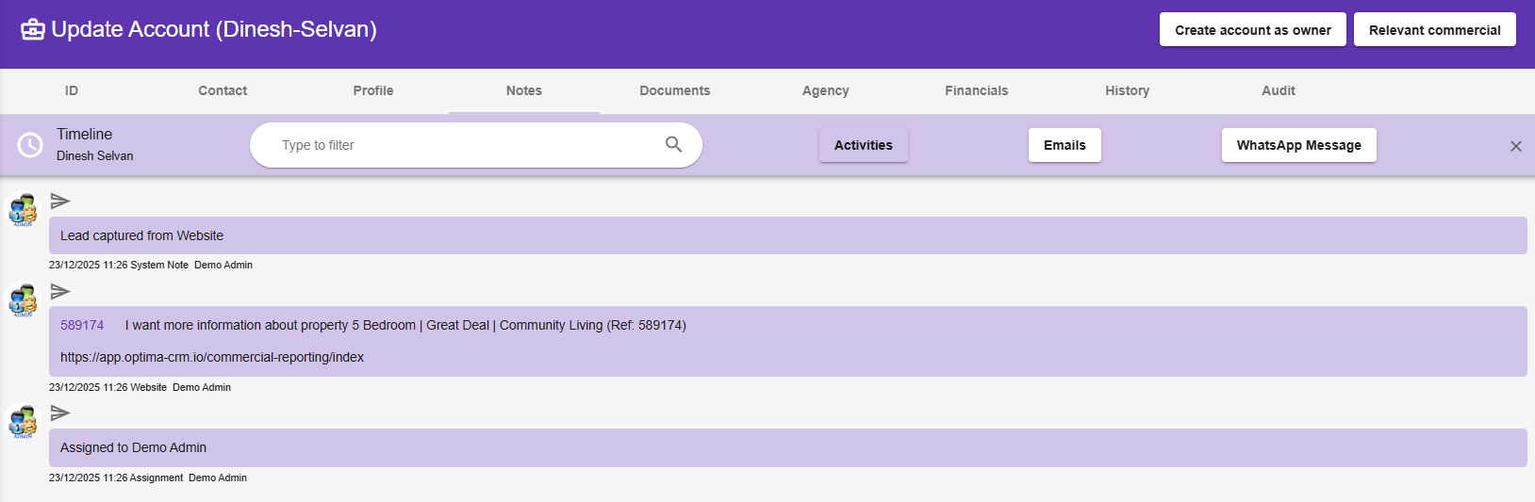
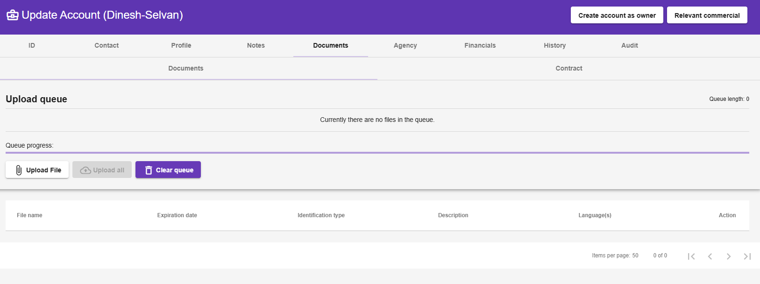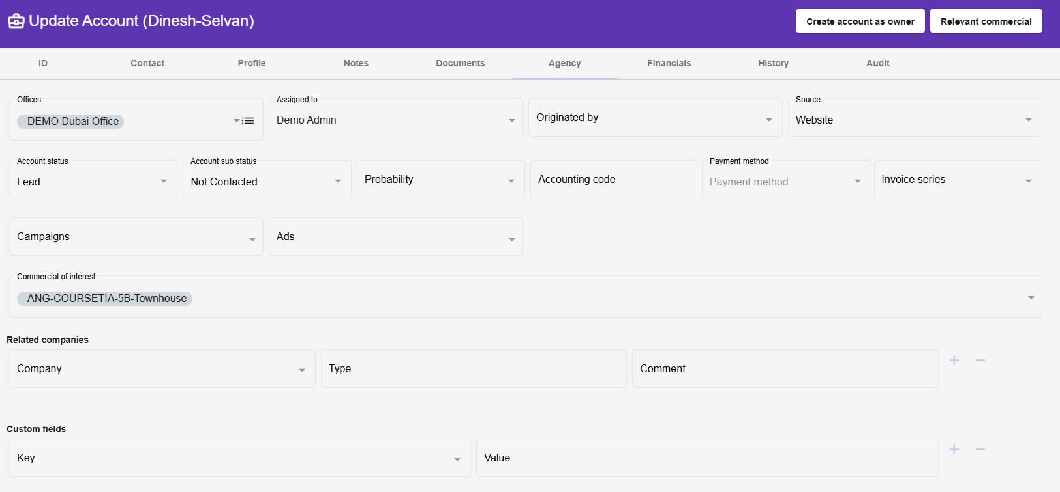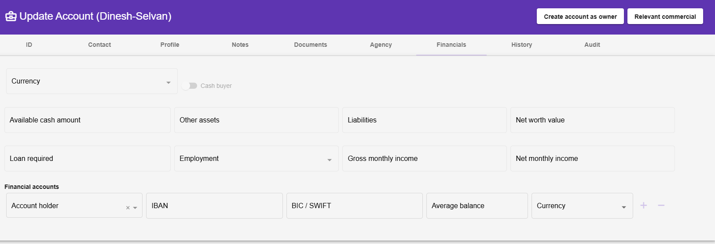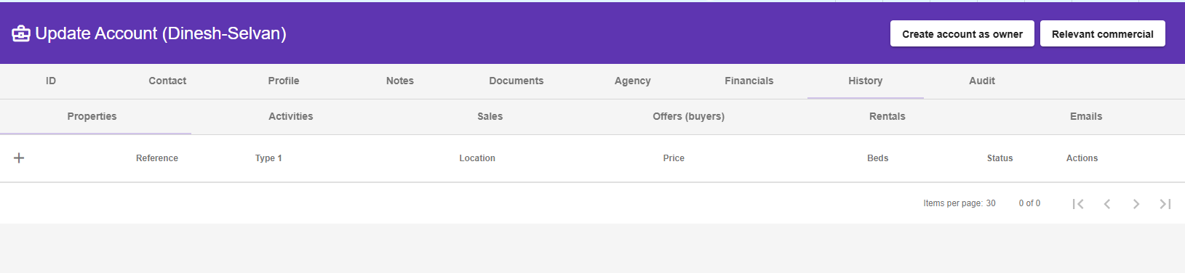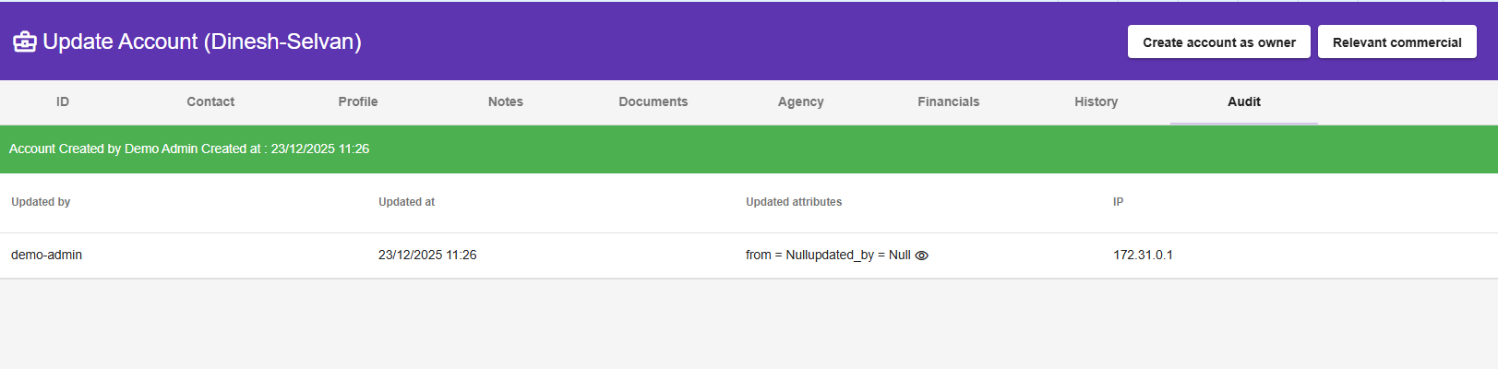
We are thinking of re-designing the list screen
Show/hide fields based on the agency type
Show/hide fields in accounts based on the module (property, bookings etc.)
The fields which should be shown when property/booking is selected
profile tab complete
agency tab: commercial of interest. Also change the translation to Properties of interest
agency tab: Related companies
history tab: hide properties, sales, offers (buyers), rentals
Hide the Create account as owner, Relavent commercials if it in non-realestate agency
In the account list, we need to concatinate the account sub-status as well. Lead - not Contacted.
Introducing Expender
add the Favorites star light. same as in properties list
The expender will be split into 3 sections
1st section: Account information which is added will be shown. data from tab (ID, Contact)
2nd section: will be showing the agency tab data
3rd section: profile (for real-esate). for non-realestate, there will be 3 secions
4th section: notes/timelines to be shown similar to mobile. when the user clicks on the notes section, we will open the timeline as a side window.
we need to add quick actions such as follow-ups (quick one). better in the 1st tab.
the tags should be shown as chips with the colors
the classification should be shown as chips
same for probability to be shown as chips

